**Name:Garige.Kalpana**

**Roll Number:2503B05117**

**Lab 14 – Web Frontend Development: AI-assisted HTML/CSS/JS with Python**

**Task Description #1 – AI-generated HTML Page**

**Task: Ask AI to generate a simple HTML homepage for a "Student Info Portal" with a header, navigation menu, and footer.**

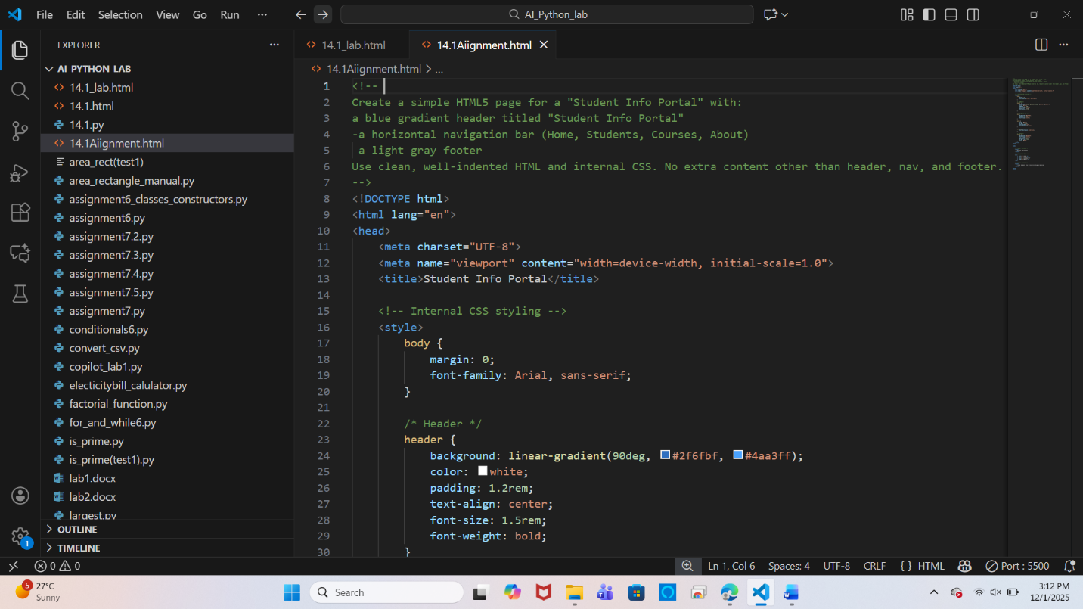

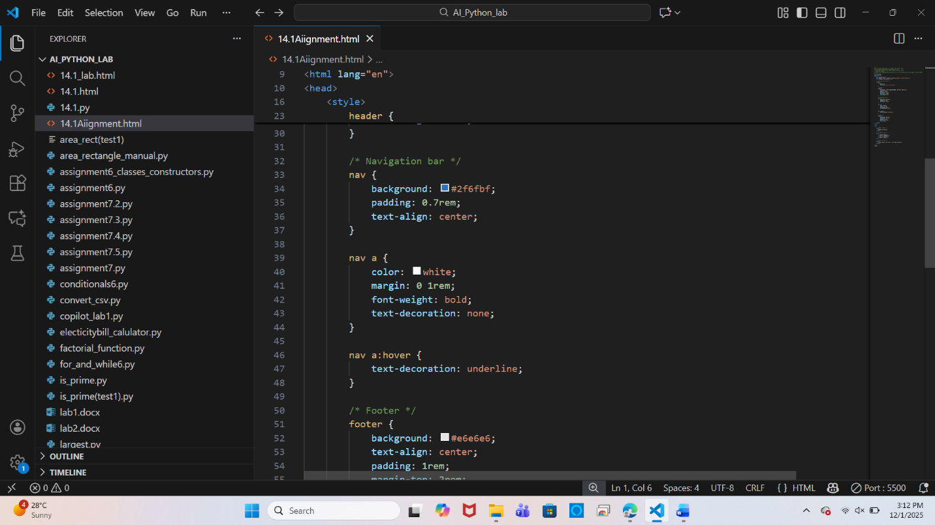

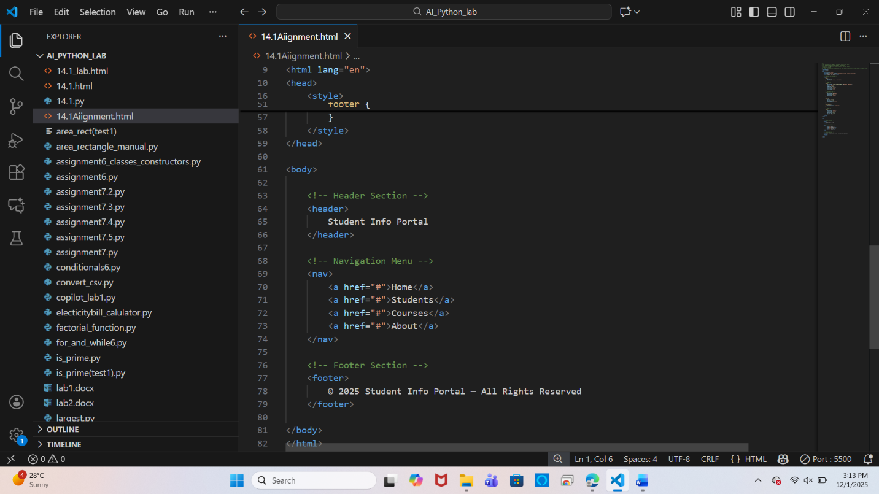

**Output:**

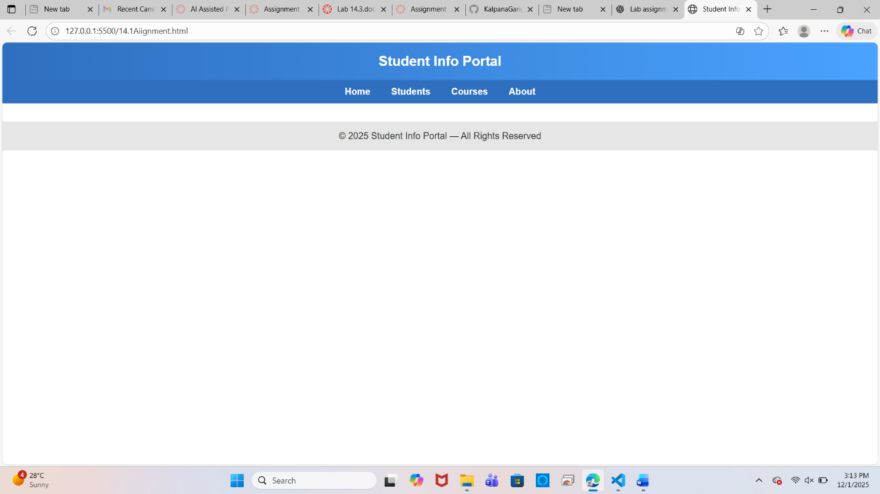

**Task Description #2 – CSS Styling**

**Task: Use AI to add CSS styling to Task #1 homepage for:**

* **Responsive navigation bar.**
* **Centered content section.**
* **Footer with light gray background.**

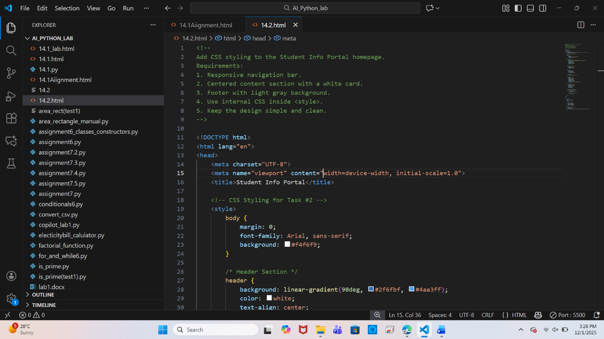

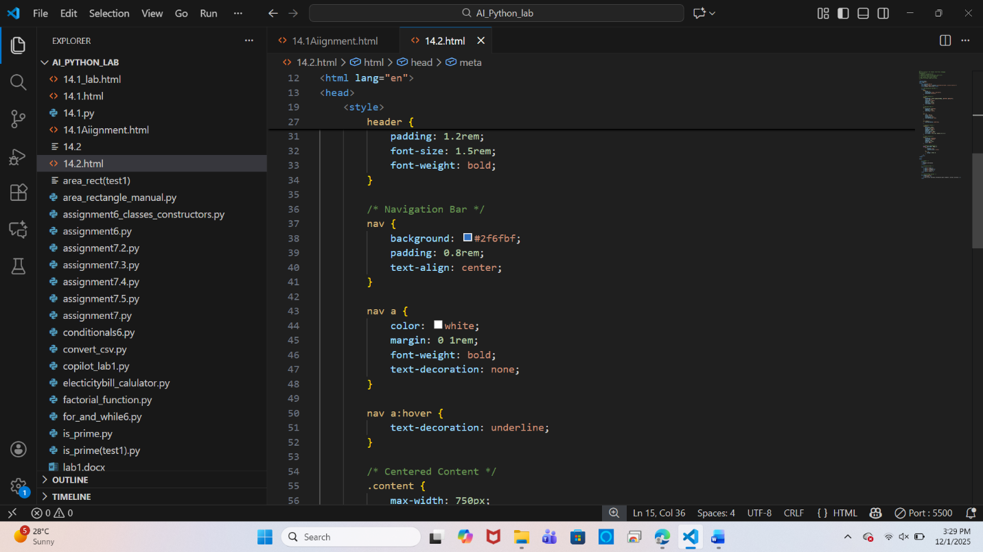

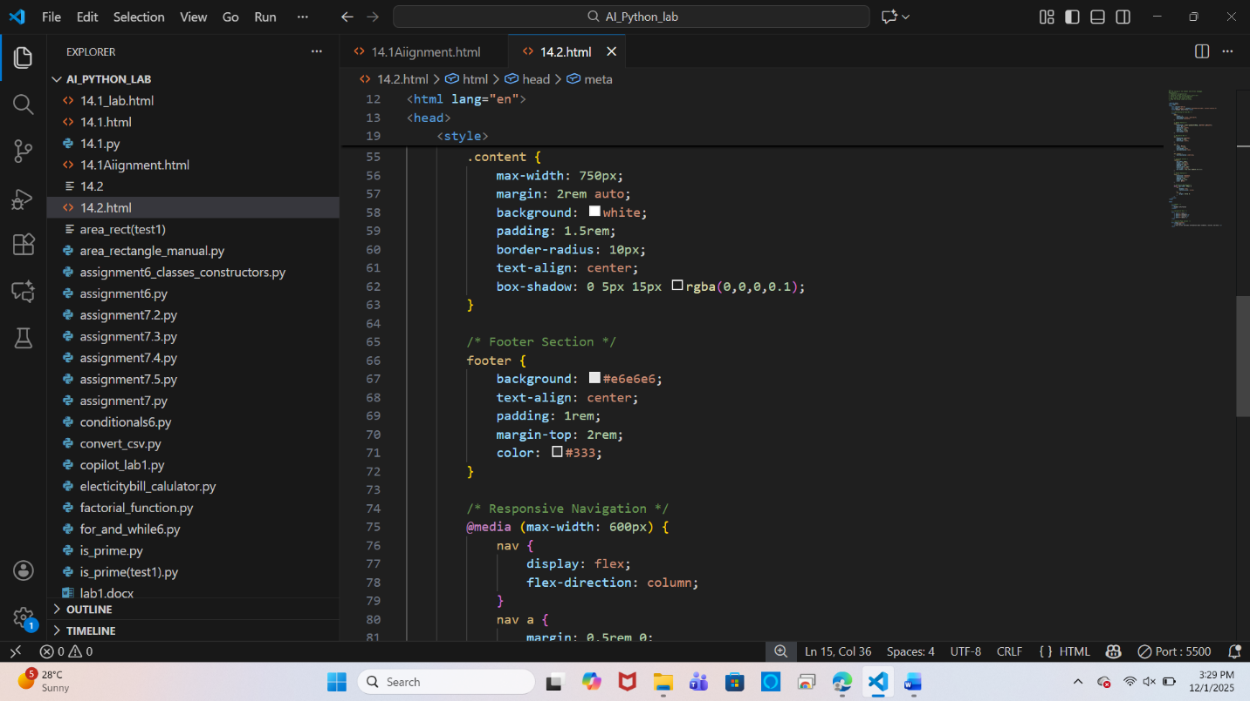

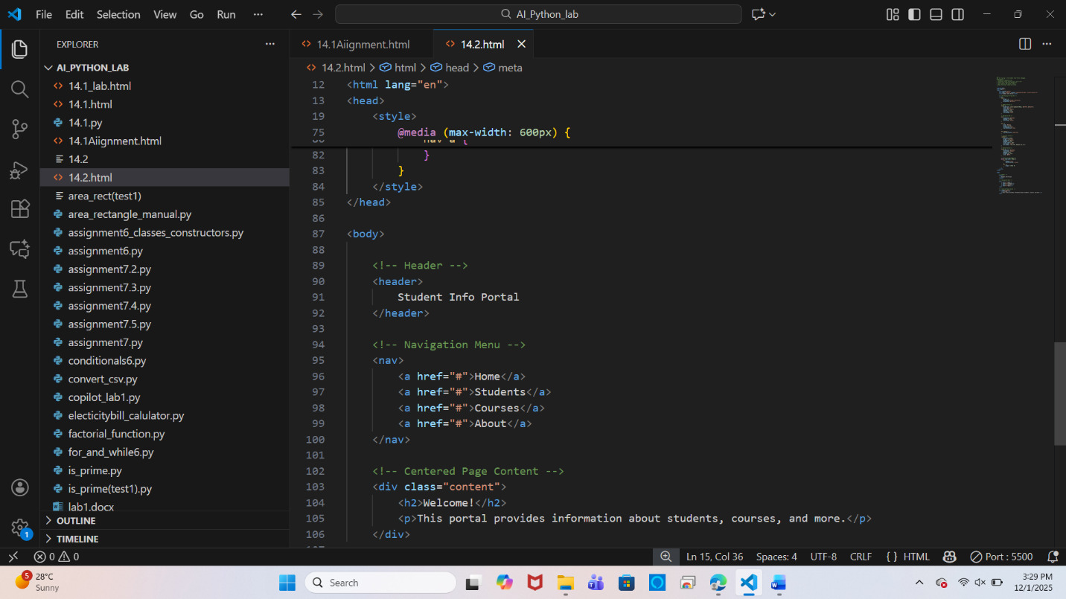

**Output:**

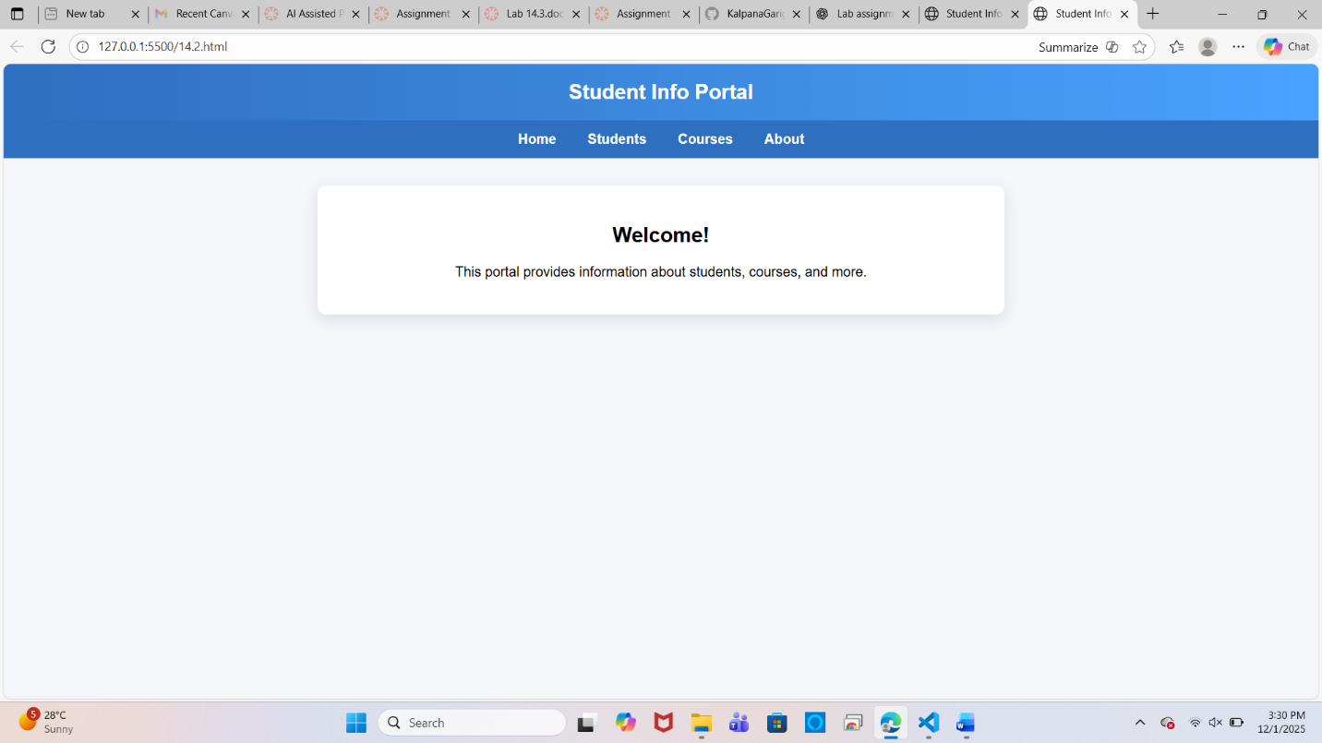

**Task Description #3 – JavaScript Interactivity**

**Task: Prompt AI to generate a JS script that validates a simple login form (non-empty username/password).**

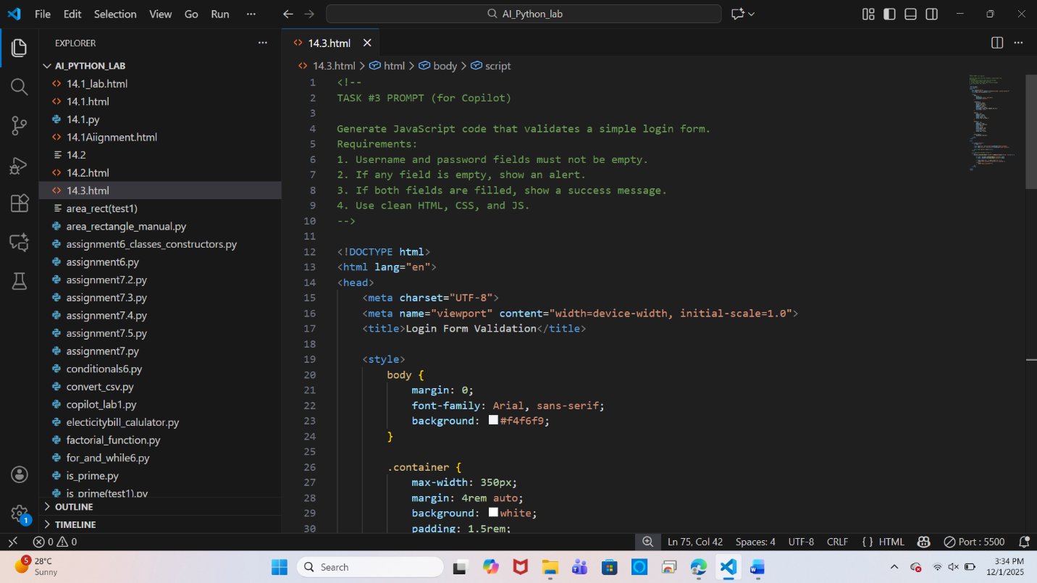

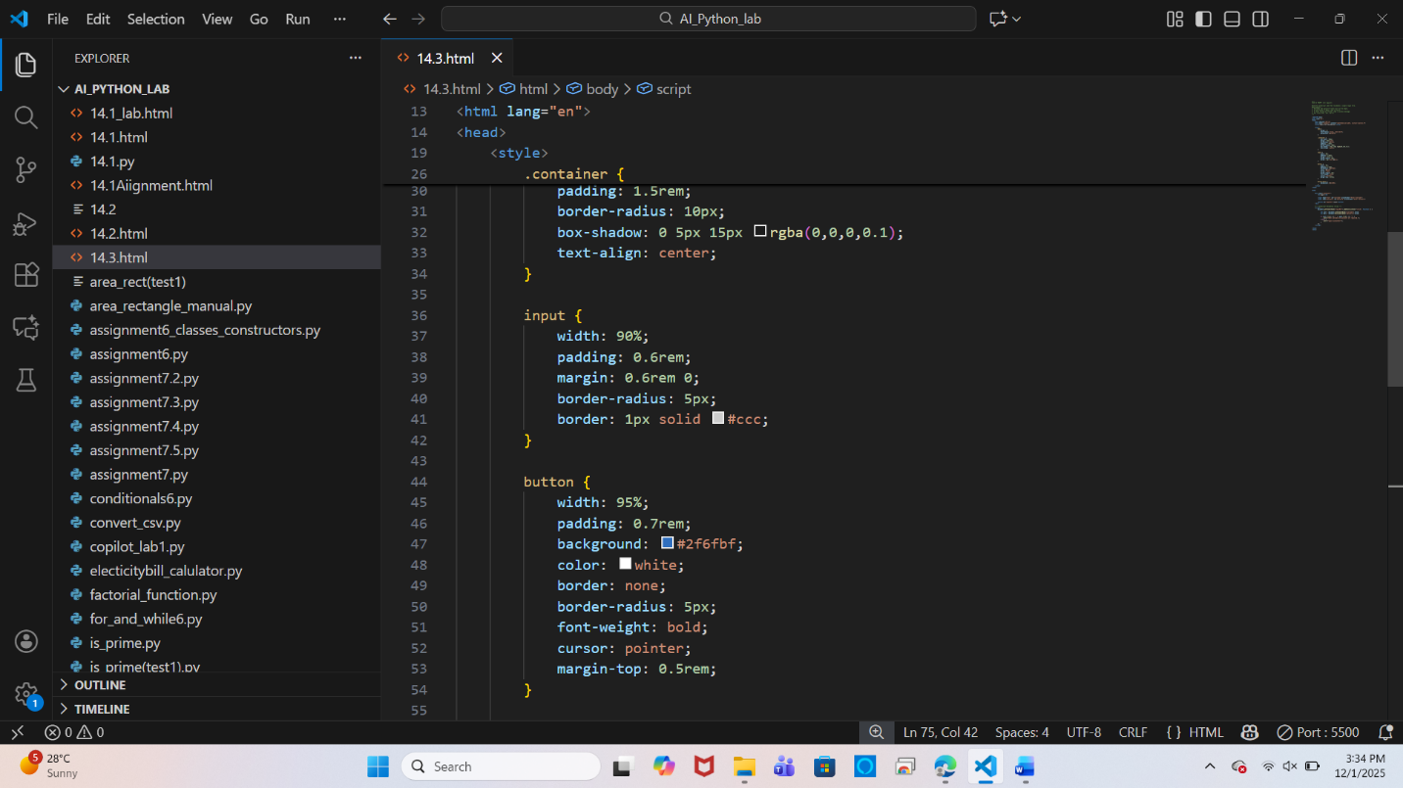

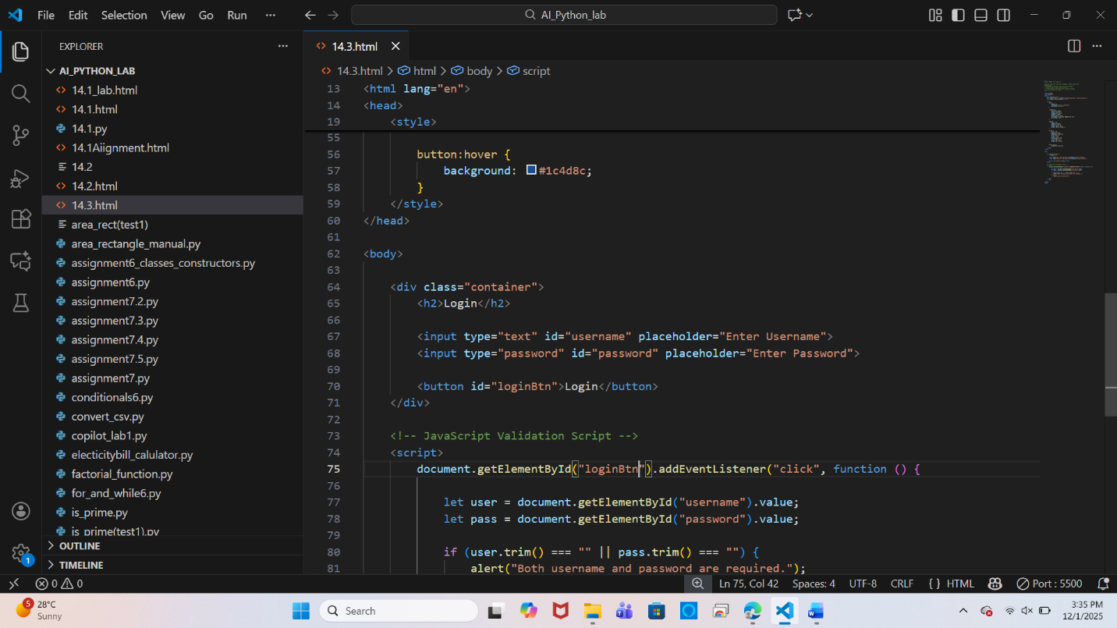

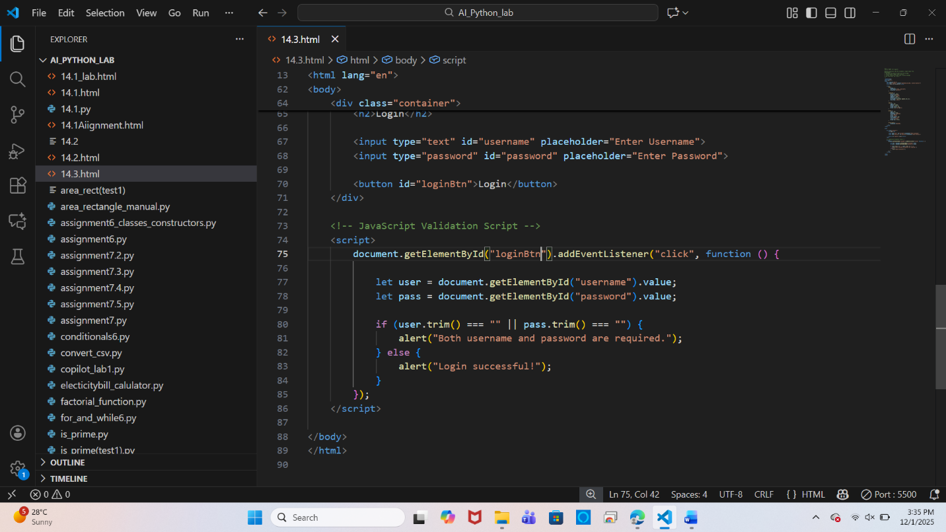

**Output:**

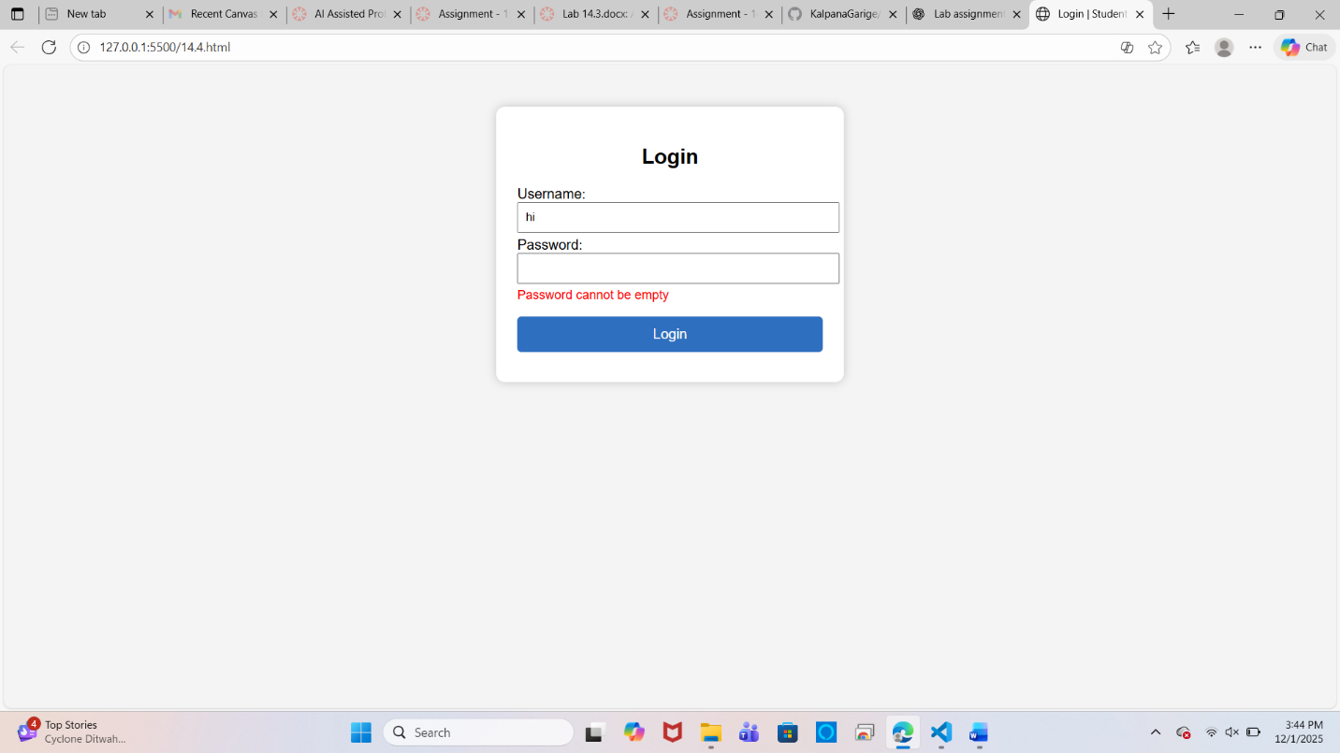

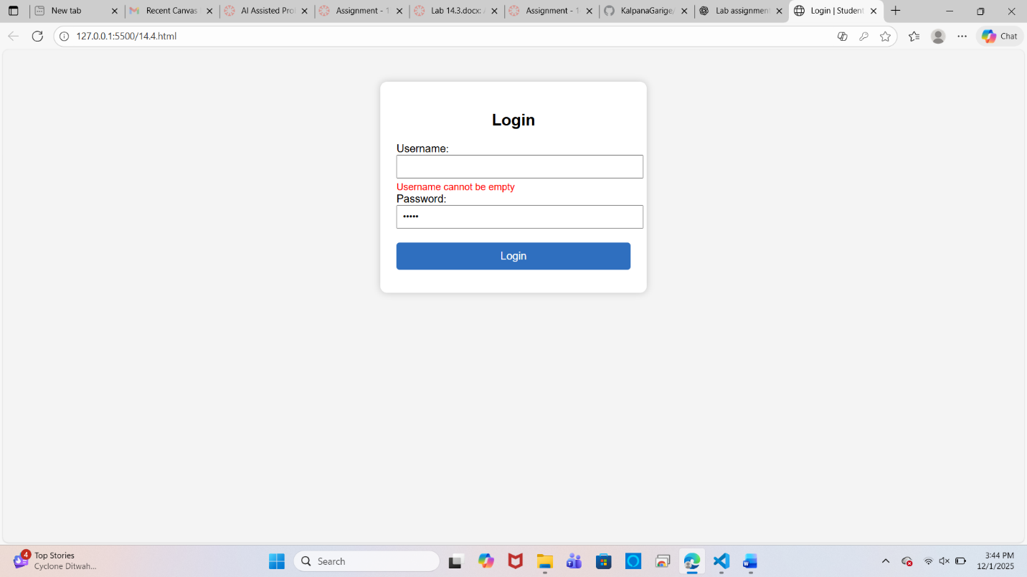

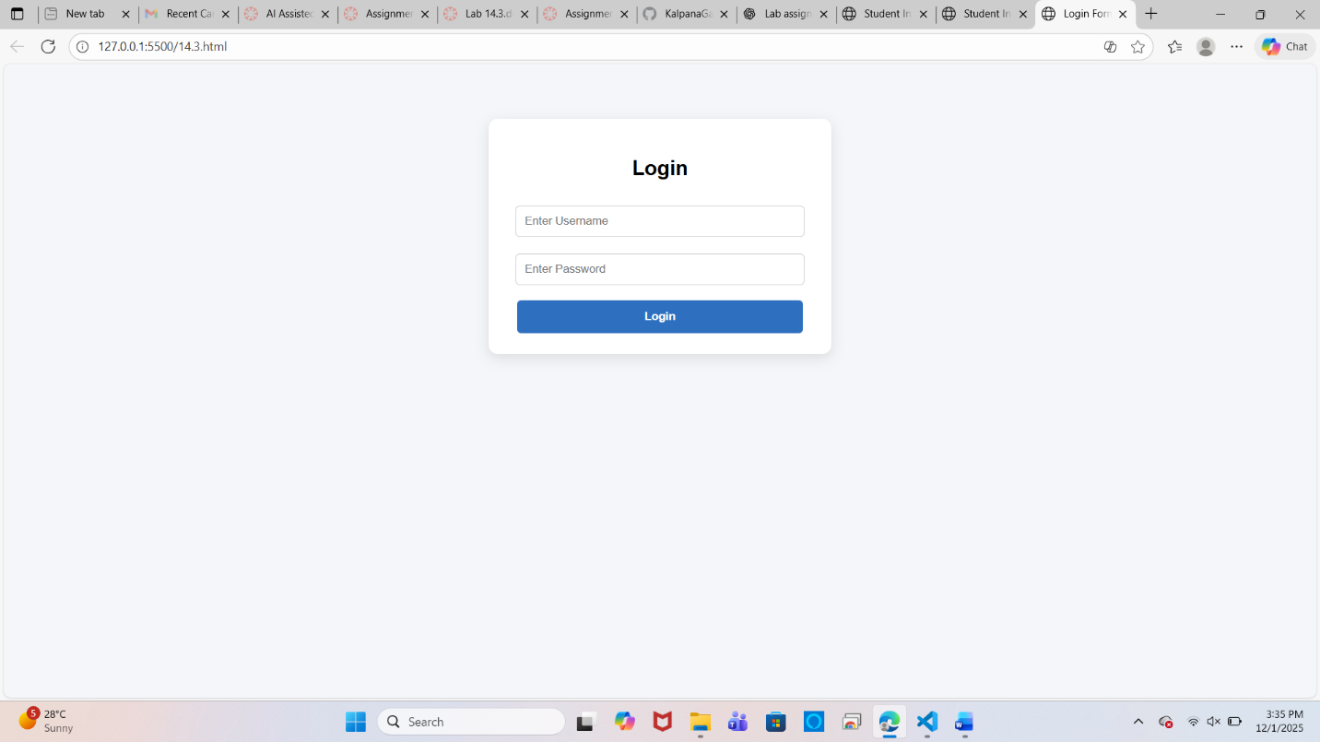

**Task Description #4 – Python Backend Integration**

**Task: Ask AI to generate a Flask app that serves the HTML form (Task #3) and prints the username on successful login**

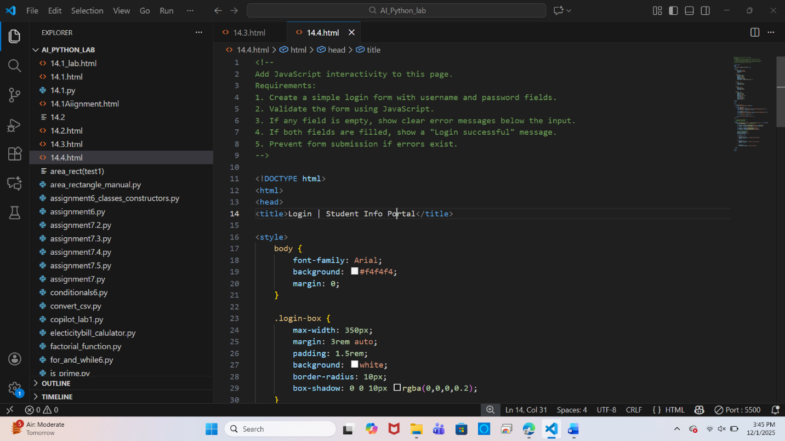

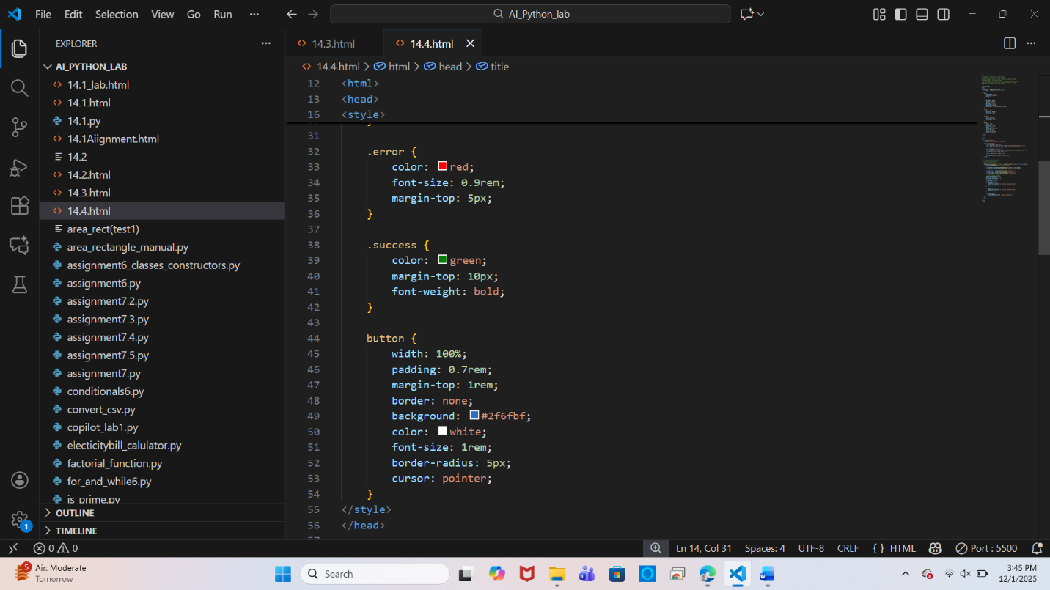

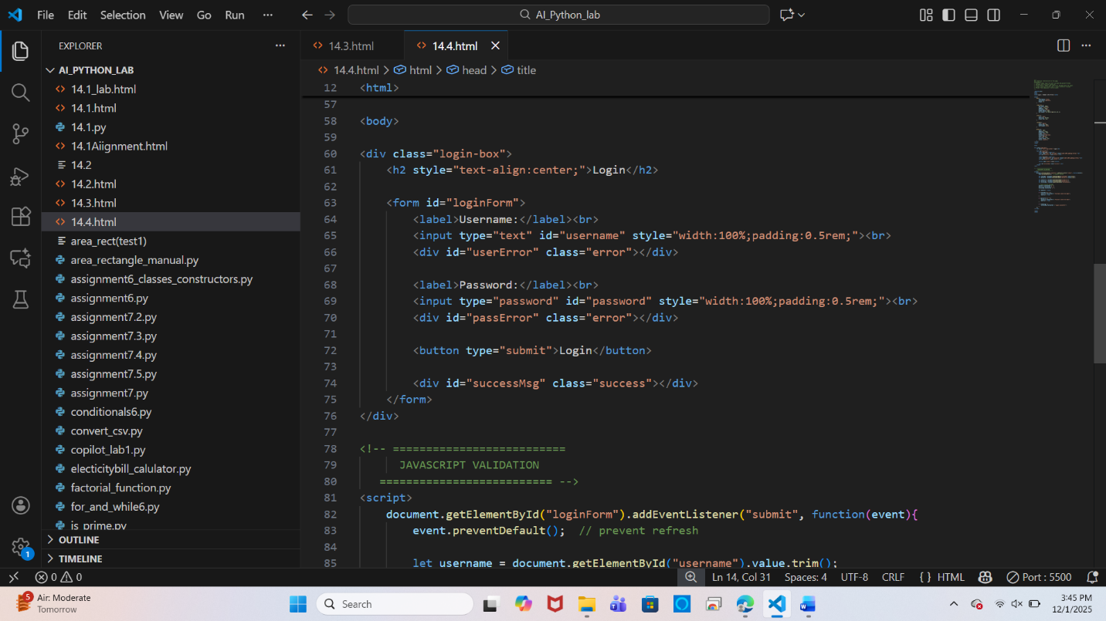

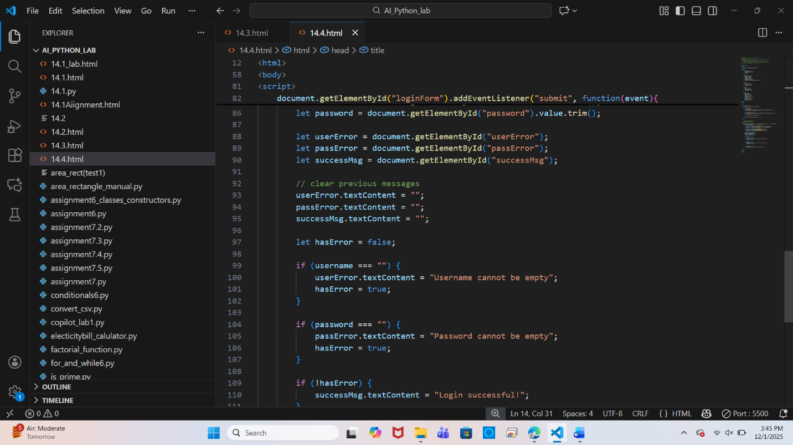

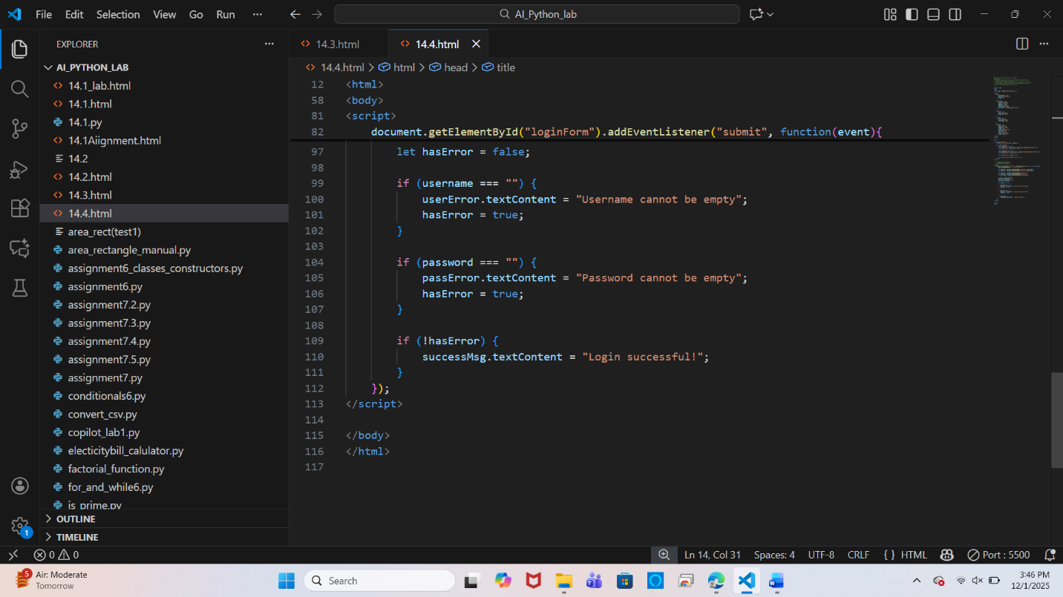

**Output:**

